I worked on this myself

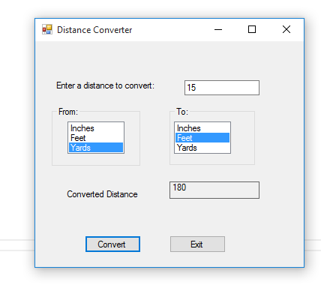

using System;

using System.Collections.Generic;

using System.ComponentModel;

using System.Data;

using System.Drawing;

using System.Linq;

using System.Text;

using System.Threading.Tasks;

using System.Windows.Forms;

namespace Disntace_Converter

{

public partial class Form1 : Form

{

public Form1()

{

InitializeComponent();

}

private void convertButton_Click(object sender, EventArgs e)

{

try

{

if (fromListBox.SelectedIndex != -1)

{

if (toListBox.SelectedIndex != -1)

{

double fromdistance, todistance;

string measureinput, measureoutput;

todistance = 0;

fromdistance = double.Parse(distanceTextBox.Text);

measureinput = fromListBox.SelectedItem.ToString();

measureoutput = toListBox.SelectedItem.ToString();

switch (measureinput)

{

case "Inches":

switch (measureoutput)

{

case "Inches":

todistance = fromdistance;

break;

case "Feet":

todistance = fromdistance / 12;

break;

case "Yards":

todistance = fromdistance / 36;

break;

}

break;

case "Feet":

switch (measureoutput)

{

case "Inches":

todistance = fromdistance * 12;

break;

case "Feet":

todistance = fromdistance;

break;

case "Yards":

todistance = fromdistance / 3;

break;

}

break;

case "Yards":

switch (measureoutput)

{

case "Inches":

todistance = fromdistance * 36;

break;

case "Feet":

todistance = fromdistance * 12;

break;

case "Yards":

todistance = fromdistance;

break;

}

break;

}

convertedDistanceLabel.Text = todistance.ToString();

}

else

{

MessageBox.Show("Please select a to measurement.");

}

}

else

{

MessageBox.Show("Please select a from measurement.");

}

}

catch( Exception ex)

{

MessageBox.Show(ex.Message);

}

}

private void exitButton_Click(object sender, EventArgs e)

{

this.Close();

}

}

}